**Algorithmic Thinking in Problem Solving**

**HashSet (Java) – Set (Python) / HashMap (Java) - Dictionary (Python)**

**NOTE:** These problems have multiple solutions. Please solve them using a set and/or a dictionary!

1. **TwoSum**

Given an array of integers, return the **indices** of the two numbers that add up to a specific target.

You may assume that each input would have ***exactly*** one solution, and you may not use the *same* element twice.

**Example:**

Given nums = [2, 7, 11, 15], target = 9,

Because nums[**0**] + nums[**1**] = 2 + 7 = 9, return [**0**, **1**].

1. **Repeated Number**

You are given an array of integers called *nums*. The numbers stored in the array appear only once except for one. Write a method that finds this number

**Example:**

nums = [3, 4, 6, 1, 3, 10, -1] return 3

1. **Most Common Word**

Given a string of words separated by spaces, find the word that appears the most in the string

**Example:**

Given “hello world hello hello world hi”

Return hello

1. **Single Number**

Given a **non-empty** array of integers, every element appears *twice* except for one. Find that single one.

**Example 1:** **Input:** [2,2,1] **Output:** 1

**Example 2: Input:** [4,1,2,1,2]**Output:** 4

1. **Keyboard Row**

Given a List of words, return the words that can be typed using letters of **alphabet** on only one row's of American keyboard like the image below.

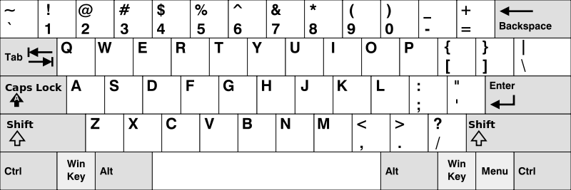

**Example:**

**Input:** ["Hello", "Alaska", "Dad", "Peace"]

**Output:** ["Alaska", "Dad"]

1. **Find the Difference**

Given two strings ***s*** and ***t*** which consist of only lowercase letters.

String ***t*** is generated by random shuffling string ***s*** and then add one more letter at a random position.

Find the letter that was added in ***t***.

**Example:**

Input:

s = "abcd"

t = "abcde"

Output:

e

Explanation:

'e' is the letter that was added.